Local Repository

Definition
# Source: AI Source: Provided by: [Data Path: Persons Table -> ID Column: 1, Name_En Column: Motasem Essam] -> From: [ChatGPT] on [2/15/2026]
A local repository is the version-controlled copy of your project that lives on your own computer. It tracks your files and their full history using Git, even without internet access.

What it does
# Source: AI Source: Provided by: [Data Path: Persons Table -> ID Column: 1, Name_En Column: Motasem Essam] -> From: [ChatGPT] on [2/15/2026]
A local repo lets you:
- Save project history (commits)
- Track file changes
- Create and switch branches
- Work offline safely
- Restore older versions of files

Where it exists
# Source: AI Source: Provided by: [Data Path: Persons Table -> ID Column: 1, Name_En Column: Motasem Essam] -> From: [ChatGPT] on [2/15/2026]
It is simply your project folder plus a hidden .git directory inside it:
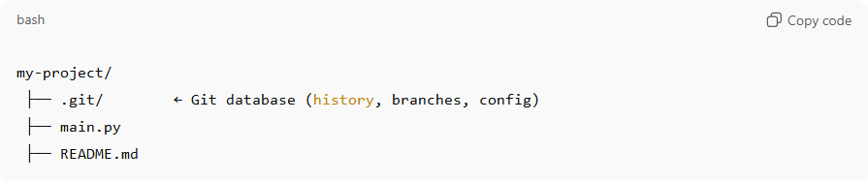
my-project/
├── .git/ ← Git database (history, branches, config)
├── main.py
├── README.md
The .git folder is what makes a normal folder a repository.

Common local repo actions
# Source: AI Source: Provided by: [Data Path: Persons Table -> ID Column: 1, Name_En Column: Motasem Essam] -> From: [ChatGPT] on [2/15/2026]

Action | Meaning
git init | Create a new local repo
git add | Stage changes
git commit | Save snapshot to history
git status | See changes
git log | View commit history
git branch | Create/manage branches

Local vs Remote repository
# Source: AI Source: Provided by: [Data Path: Persons Table -> ID Column: 1, Name_En Column: Motasem Essam] -> From: [ChatGPT] on [2/15/2026]

Local Repo | Remote Repo
On your computer | On internet/server
Works offline | Needs internet
Personal work | Collaboration & backup
Fast | Shareable

Simple explanation
# Source: AI Source: Provided by: [Data Path: Persons Table -> ID Column: 1, Name_En Column: Motasem Essam] -> From: [ChatGPT] on [2/15/2026]
A local repository = your project with a built-in time machine stored on your computer.

